Pico walk

STEP 1: Collect all the Required Material

1. 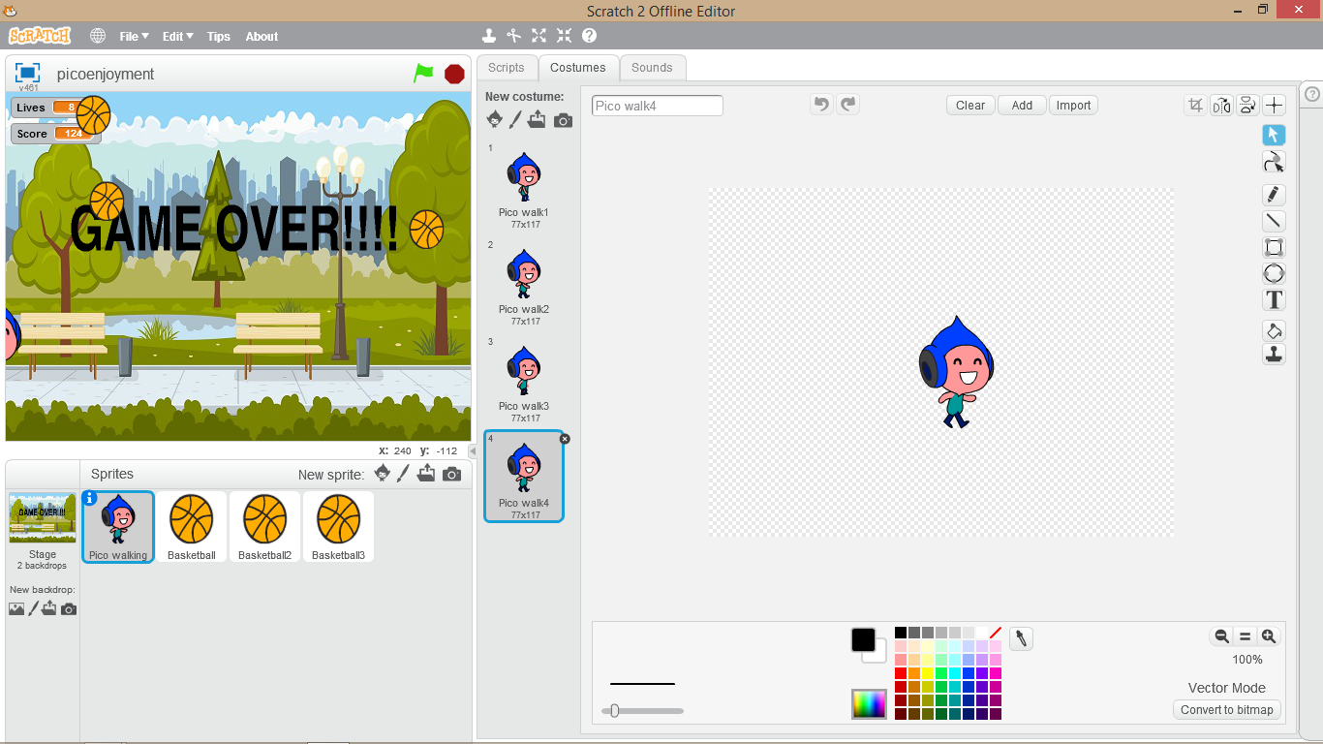Your character

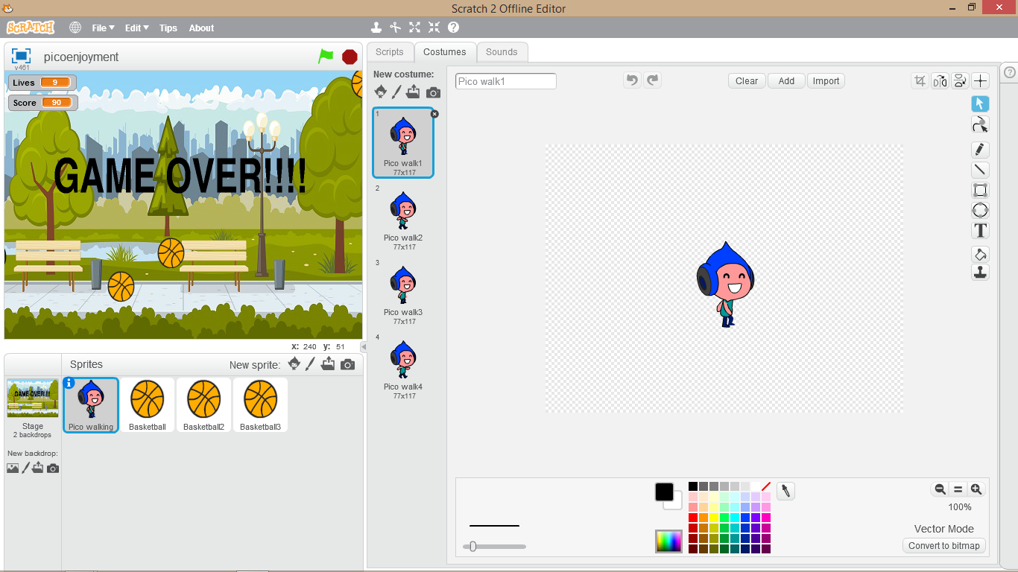

1. 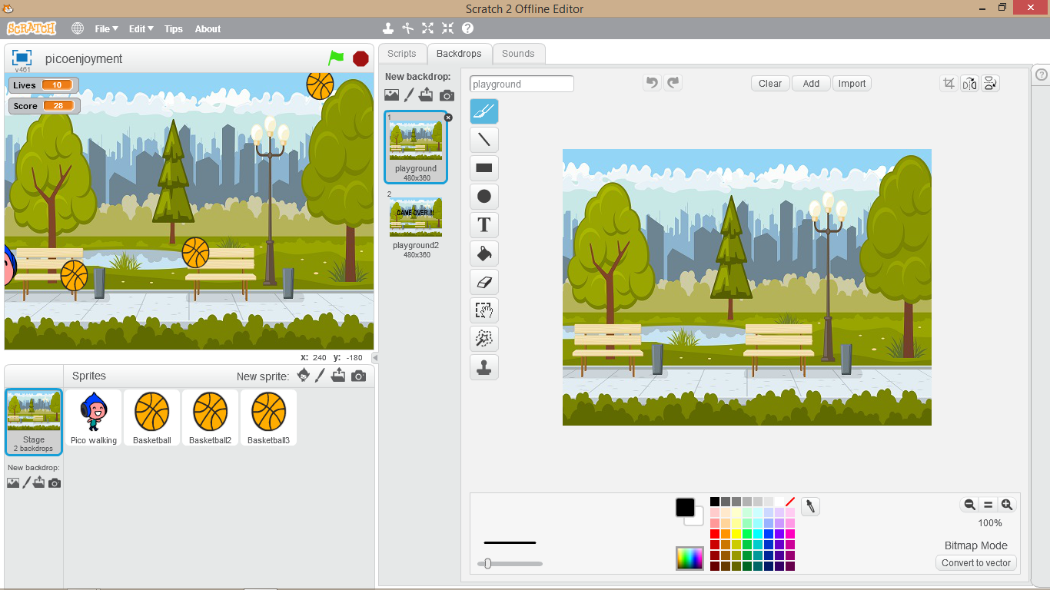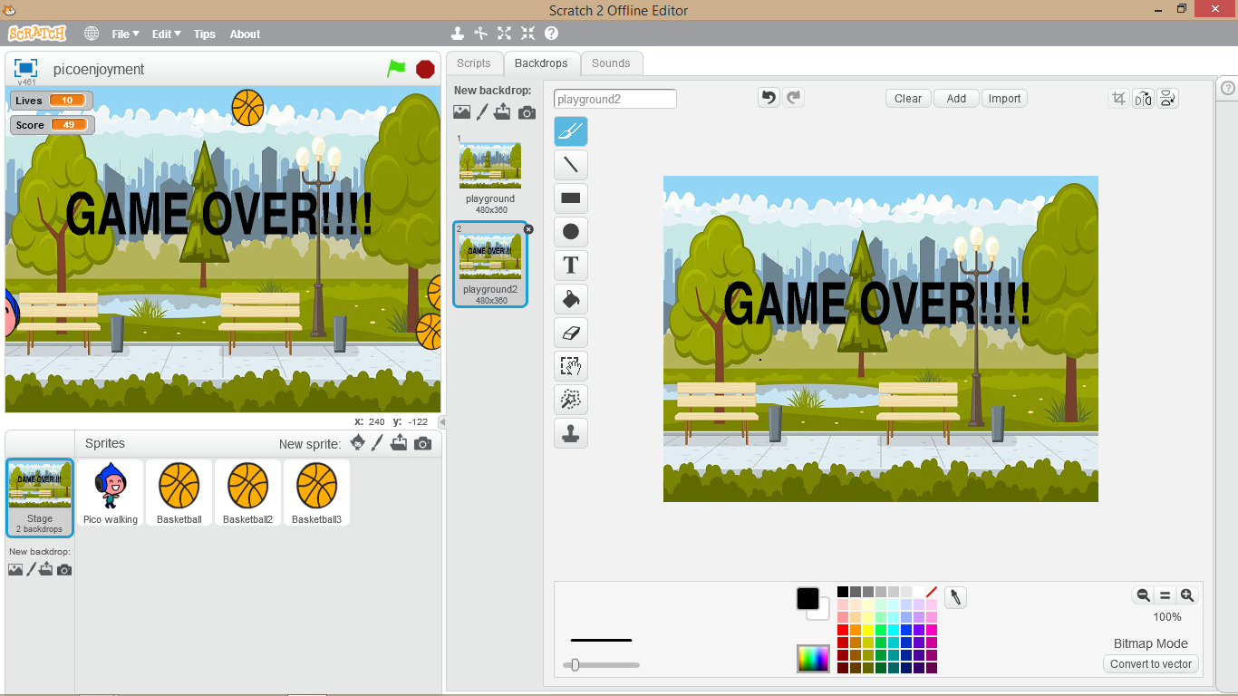Background image
2. Music and Sound

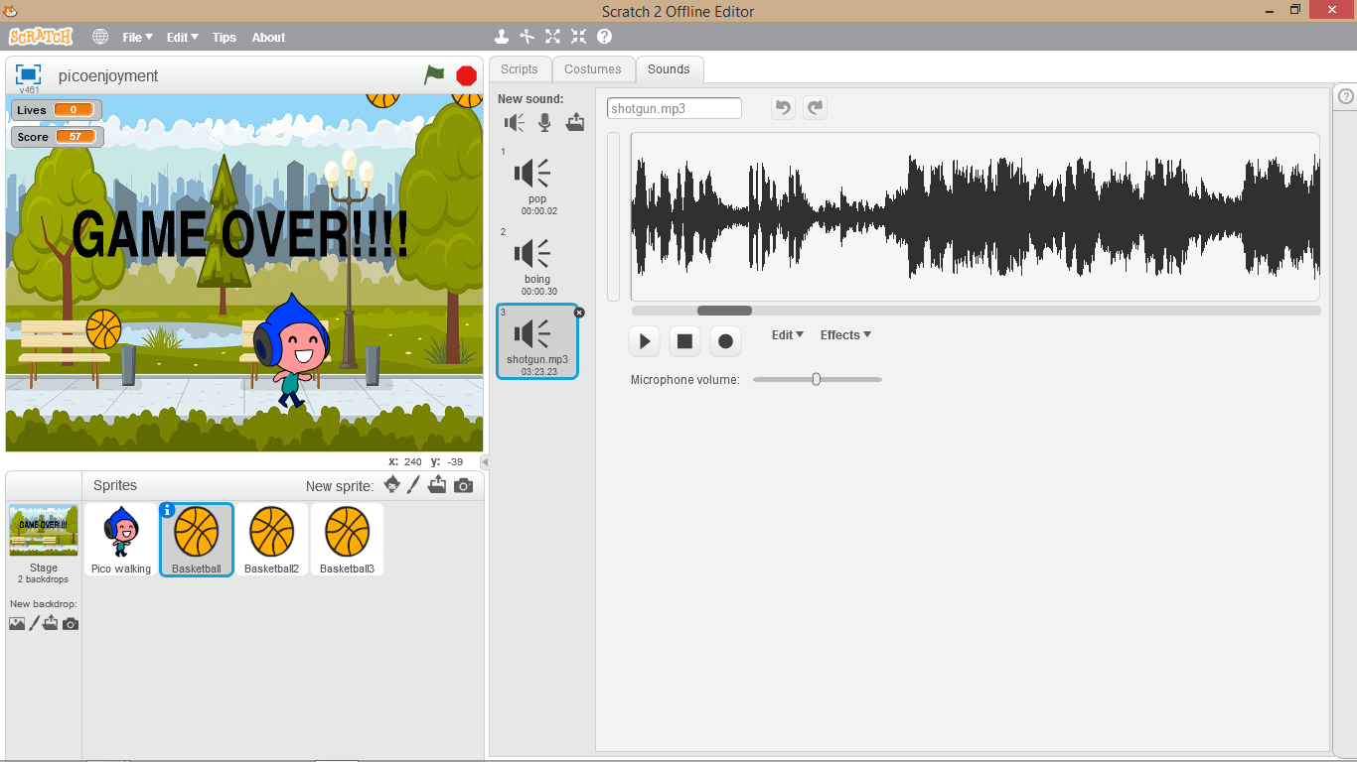

STEP 2:

1. 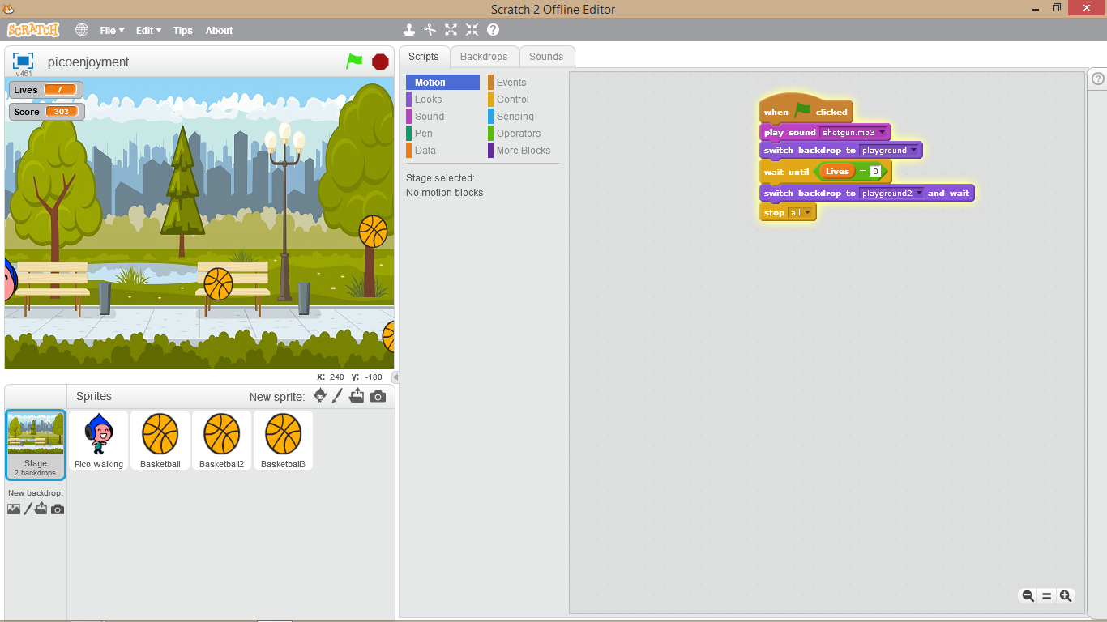Write Algorithm for every picture in our Game.(For proper view of Algorithm zoom the doc file)

* For our background image

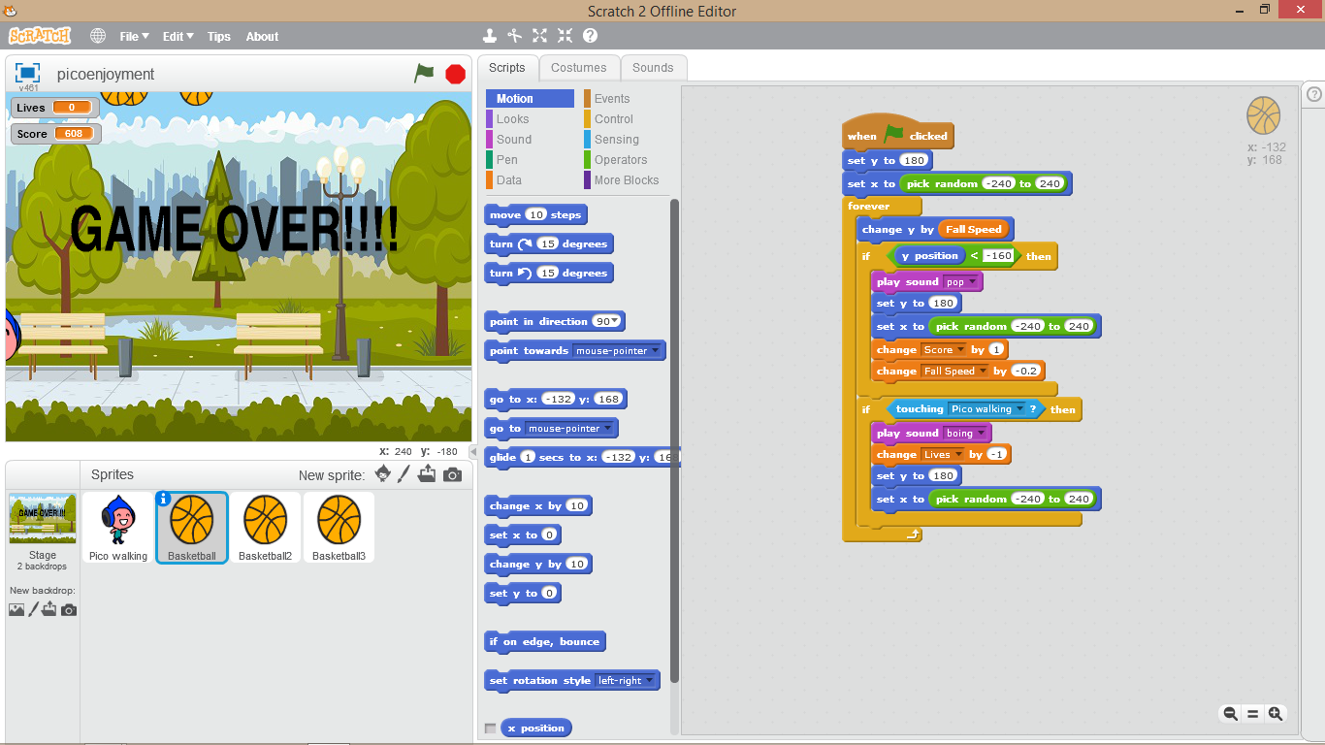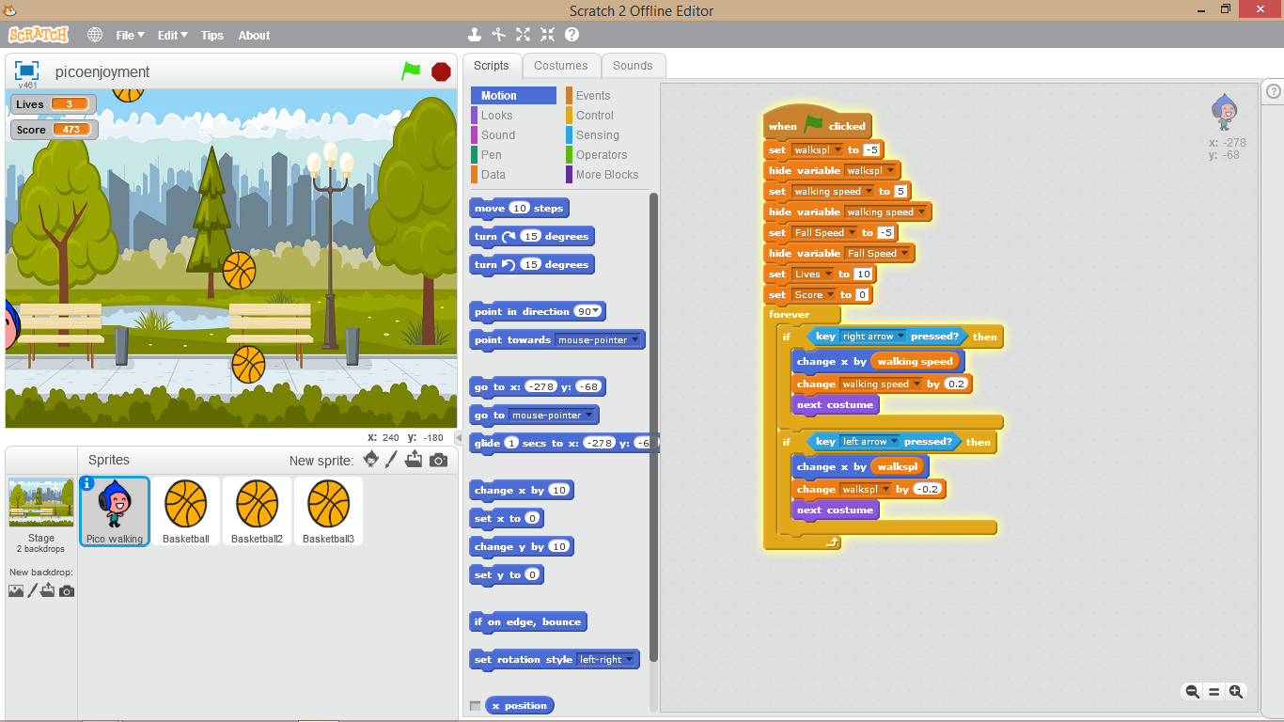

* For the basketball
* For PICO
* For our PICO

* Make two duplicate of basketball and set wait of 0.3 and 0.6 sec in them to make the Game more interesting.

If you did everything exactly as mentioned then your game is like the video I have posted.